Measurement Protocol PAM

# General Information:

|  |  |  |
| --- | --- | --- |
| Test date: 24/08/19 | Date prev. test: | Test number: 1 |
| Tested by: Sarah Schoultz | PAM number: 2 | Installed at ant.: NA |
| Comments: | | |
|  | | |
|  | | |
|  | | |
| Known problems: Low gain so there is one or more broken amplifiers | | |
|  | | |
|  | | |
|  | | |

# Setup:

|  |  |  |  |
| --- | --- | --- | --- |
| Power supply: | OK 🗹 NOK 🗆 | Communication: | OK 🗹 NOK 🗆 |
| Supply current +6V: 1.120mA | | ssh obs@antcntl | |
| Supply current -6V: 0.115mA | | ssh ataant@ant0 | pw: q@n@t |
| Supply current +5V: 0.333mA | | telnet pax | “help” |
|  | | CTRL + ] | “close” |

# RF Test with VNA:

### VNA Setup:

|  |  |  |
| --- | --- | --- |
| Load configuration: Passband_PAX.csa | | |
| Freq Start: 1.0 GHz | Freq Stop: 13.0 GHz | Power Level: -20 dBm |
| Averaging: enabled | Averaging count: 15 | N. Points: 801 |
| VNA : Agilent N5230C 10MHz - 20GHz | | |

|  |  |  |  |  |
| --- | --- | --- | --- | --- |
| VNA to PAX connection: | 1m ABC-CA18 Cable + 20dB Attenuator | | | |
| Input Power Level to PAX: (Measured) | @1GHz:  -40.2dBm | @4GHz:  -40.7dBm | @8GHz: -41.2dBm | @12GHz: -41.4dBm |

|  |  |
| --- | --- |
| PAX to VNA connection: | 2m Fibre Cable + Fibre Diode + AOX Amplifier + 1m ABC-CA18 Cable |

### Measured Passband with Attenuator set to 7dB each (Complete Link):

|  |  |  |  |
| --- | --- | --- | --- |
| Flatness: | OK 🗆 NOK 🗹 | Unwanted Features: | Yes 🗹 No 🗆 |

### Power Sweep (Complete Link):

|  |  |  |
| --- | --- | --- |
| Load configuration: Power_Sweep_PAX.csa | | |
| Power Start: -40dBm | Power Stop: -20dBm | Frequency : 4.0GHz |
| PAM Attenuator: 0dB |  | N. Points: 801 |

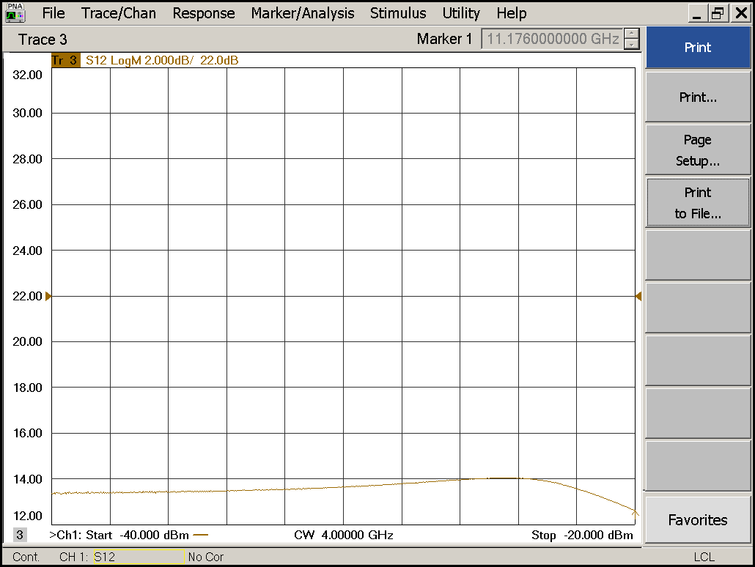

|  |  |  |  |
| --- | --- | --- | --- |
| Compression point: | OK 🗹 NOK 🗆 | Unwanted Features: | Yes 🗹 No 🗆 |

### Detector Calibration and Attenuator Sweep:

|  |  |  |
| --- | --- | --- |
| Load configuration: Detector_Calibration_PAX.csa | | |
| Freq : 4.0 GHz | Power Level: -20dBm | Sweep Time: -20sec |
| Sweep Mode: CW | Power Level at PAX Input (Measured): -40.6dBm | |

|  |  |  |  |  |
| --- | --- | --- | --- | --- |
|  | | | | |
| CW Input Power [dBm]: | Attenuator Value A [dB]: | Attenuator Value: B [dB]: | Detector Value: | Power Meter  Value [dBm]: |
| -40.6 | 0 | 0 | 0.4640 | 9.1 |
| -40.6 | 0 | 3 | 0.3297 | 6.9 |
| -40.6 | 0 | 6 | 0.2110 | 4.1 |
| -40.6 | 0 | 9 | 0.1282 | 1.1 |
| -40.6 | 0 | 12 | 0.0755 | -1.9 |
| -40.6 | 0 | 15 | 0.0434 | -4.9 |
| -40.6 | 0 | 18 | 0.0229 | -8.2 |
| -40.6 | 0 | 21 | 0.0129 | -11.2 |
| -40.6 | 3 | 21 | 0.0067 | -14.5 |
| -40.6 | 6 | 21 | 0.0039 | -17.5 |
| -40.6 | 9 | 21 | 0.0024 | -20.4 |
| -40.6 | 12 | 21 | 0.0017 | -23.4 |
| -40.6 | 15 | 21 | 0.0013 | -26.3 |
| -40.6 | 18 | 21 | 0.0010 | -29.9 |
| -40.6 | 21 | 21 | 0.0009 | -32.9 |
| -40.6 | 24 | 21 | 0.0010 | -35.7 |
| -40.6 | 27 | 21 | 0.0009 | -38.7 |
| -40.6 | 30 | 21 | 0.0009 | -41.8 |
| -40.6 | 30 | 24 | 0.0009 | -44.0 |
| -40.6 | 30 | 27 | 0.0009 | -46.1 |
| -40.6 | 30 | 30 | 0.0009 | -47.6 |

|  |  |  |
| --- | --- | --- |
| Use Noise Source: Atlantic AS6333 | | |
| Freq : 1.0 - 12.0GHz | Power Level: -41.8dBm |  |
| DC Supply: 28V |  | |

|  |  |  |  |  |
| --- | --- | --- | --- | --- |
|  | | | | |
| CW Input Power [dBm]: | Attenuator Value A [dB]: | Attenuator Value: B [dB]: | Detector Value: | Power Meter  Value [dBm]: |
| -41.8 | 0 | 0 | 0.4112 | 6.1 |
| -41.8 | 0 | 3 | 0.3292 | 4.2 |
| -41.8 | 0 | 6 | 0.2217 | 1.6 |
| -41.8 | 0 | 9 | 0.1398 | -1.1 |
| -41.8 | 0 | 12 | 0.0800 | -4.2 |
| -41.8 | 0 | 15 | 0.0495 | -6.8 |
| -41.8 | 0 | 18 | 0.0249 | -10.1 |
| -41.8 | 0 | 21 | 0.0141 | -12.9 |
| -41.8 | 3 | 21 | 0.0079 | -15.8 |
| -41.8 | 6 | 21 | 0.0047 | -18.8 |
| -41.8 | 9 | 21 | 0.0030 | -21.7 |
| -41.8 | 12 | 21 | 0.0022 | -24.8 |
| -41.8 | 15 | 21 | 0.0018 | -27.4 |
| -41.8 | 18 | 21 | 0.0015 | -30.9 |
| -41.8 | 21 | 21 | 0.0014 | -34.0 |
| -41.8 | 24 | 21 | 0.0014 | -37.0 |
| -41.8 | 27 | 21 | 0.0013 | -39.6 |
| -41.8 | 30 | 21 | 0.0014 | -42.8 |
| -41.8 | 30 | 24 | 0.0013 | -45.0 |
| -41.8 | 30 | 27 | 0.0013 | -46.5 |
| -41.8 | 30 | 30 | 0.0013 | -47.9 |